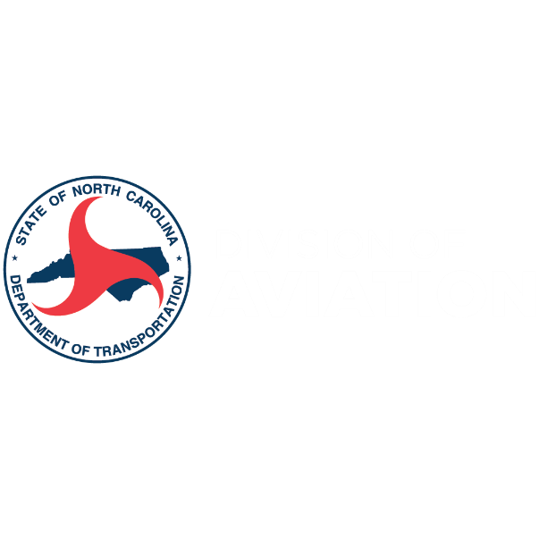
North Carolina: The State of Aviation
Social Media Toolkit

(f or use following report release Jan. 3, 2025)

Please find below a selection of drafted social media posts designed to help promote the economic impact of your airport. Feel free to tweak, edit, or adjust the text to best suit your airport's voice and messaging.

These posts are a starting point, and we encourage you to personalize them to reflect your airport’s unique contributions to job creation, local income, and economic growth.

Post One
📊 [Airport Name] is proud to contribute to North Carolina’s economy, supporting [X] jobs, generating [$X] in personal income, and creating [$X] in economic output. Together, we’re driving growth and prosperity for our community.
#EconomicImpact #NCAirports #StateofAviation
Image/Video Ideas:
- A clean infographic highlighting key statistics (jobs, income, taxes, output).
- A photo of the airport with overlay text showing the key figures.

Post Two
🛫 [Airport Name] supports a thriving workforce, with [X] jobs created locally. From ground operations to customer service, we’re proud to contribute to job growth in North Carolina.
#EconomicImpact #NCAirports #StateofAviation
Image/Video Ideas:
- A photo of employees working at the airport with a stat overlay showing the number of jobs.

Post Three
💼 [Airport Name] plays a key role in generating [$X] in state and local taxes, helping fund vital services and infrastructure. Together, we’re building a stronger future for North Carolina.
#EconomicImpact #NCAirports #StateofAviation

Post Four
📈 [Airport Name] generates [$X] in economic output, fueling growth in industries across North Carolina. We're proud to be part of the state's economic engine.
#NCAirports #StateofAviation

Post Five
🔑 [Airport Name] is a key driver of North Carolina’s economy, contributing [$X] in economic output. We’re proud to be a catalyst for business growth, tourism, and local development.
#NCAirports #StateofAviation
Image/Video Ideas:
- A dynamic image of the airport with various business sectors highlighted (e.g., retail, transportation, tourism).
- A video of local business owners talking about the airport's positive impact on their businesses.

Post Six
💰 [Airport Name] generates [$X] in personal income, supporting families and local businesses across North Carolina. Our airport is more than a gateway to travel—it's a vital economic driver.
#NCAirports #StateofAviation #Jobs
Image/Video Ideas:
- Showcase different departments within the airport (e.g., baggage handling, security, operations) to highlight the people behind the jobs and the overall contribution to the economy.
- A collage of staff working in different airport roles with overlay text showing the number of jobs supported.

Post Seven
🌍 [Airport Name] is more than an airport—it's a vital part of our region's economic success. With [$X] in economic output and [X] jobs supported, we’re helping build a prosperous future for North Carolina.

#NCAirports #StateofAviation #Jobs

